How to Deposit Kenyan Shilling (KES) on Golix

Assuming you have already logged in to your account, kindly follow these simple steps:-

- Click on your KES Wallet as indicated in the diagram below



- Click on the Deposit Tab and fill in how much you want deposit and click on CHECKOUT WITH DUSUPAY, as shown in the diagram below.

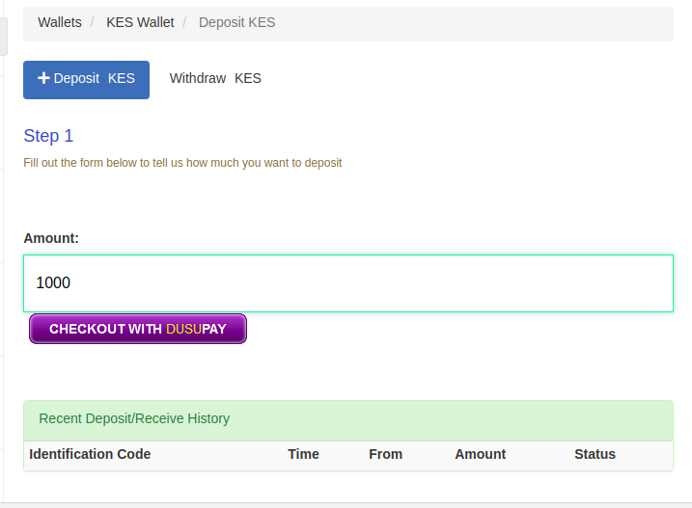

- Select your payment option from the list that you wish to use e,g Mpesa Mobile Money or Kenya Local Cards.
- Fill in your details eg Phone number, name , Email (optional).
- Each time you make a deposit make sure it appears on you Transaction History.

